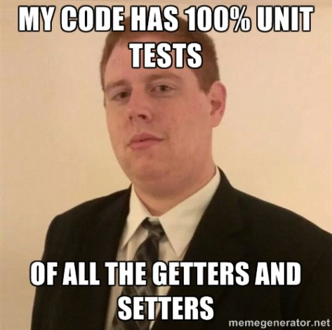**Release: software**

So, having been tinkering for a bit, I’ve written the functions to calculate expressions for MINOL. This is considerably simpler than BASIC , because there is no order of precedence, and only four terms, integer constant, variable A-Z, random# (!) and memory access (144,1).

The code is actually just the expression and the test code, which is python generated expressions which are then run and compared with the calculated answer.